







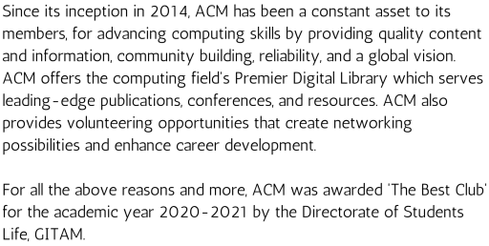





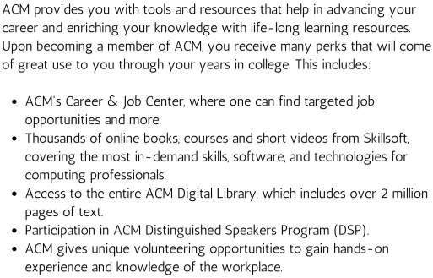





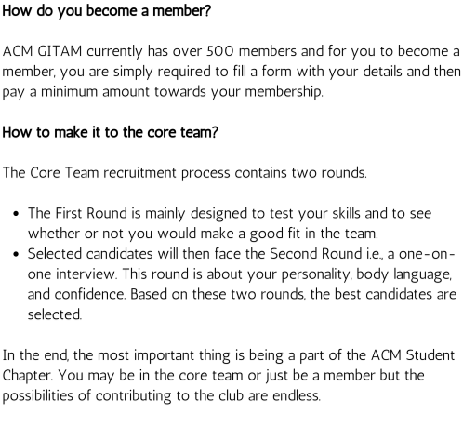





https://www.linkedin.com/company/acm-gitam-association-for-computing

machinery

https://www.youtube.com/channel/UCWtiBaDPrpI1MRxkwP9SB1w/featured

https://medium.com/@acm-gitam

https://instagram.com/gitam_acm?utm_medium=copy_link



Join Group 1 Here!

Join Group 2 Here!

Join Group 3 Here!